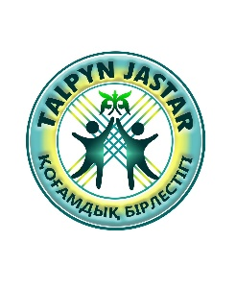Office 608, 50, Zhibek zholy street, PA «TALPYN JASTAR»

Almaty city, The Republic of Kazakhstan Charity Foundation

contact number: +7 777 082 2492 / +7 707 262 6272

email: talpynjastar09@gmail.com

website: httpc://tjastar.kz/

from: Chairperson of "Talpyn Jastar" Public Association

Karima Abdrakhmanova

REQUEST LETTER

Dear Sir/Madam,

Our public association is engaged in charitable activities: buys and delivers food, medicine, allocates small amounts of money, provides temporary housing and other necessary assistance to people below the poverty line. As well, our association has a project to start an adaptation center for returnees in order to help and support them in the new environment like education, Kazakh traditions and customs, developing traditional Kazakh games among children of the returnees, who lost their national identities.

The members of the Charity Foundation carry out their activities through contributions and donations, and on a free basis.

I dare to ask you to support us and make a contribution in the form of a donation to our bank account.

"TALPYN JASTAR" Kogamdyk Birlestigi (Public Association)

BSN/BIN: 190440015990

Legal entity address:

Street Zhibek Zholy, 50, office 608

Almaty city, Republic of Kazakhstan

post code: 050000

Personal account: KZ39998CTB0000471527

Bank: JSC “First Heartland Jysan Bank”

BIC: TSESKZKA

KBE: 18

KNP: 119

Sincerely, Karima Abdrakhmanova 